Exponential (Scientific) notation
In exponential notation float value uses a special character “e” or “E”. The value of “e” or “E” is 10.

>>> a=1.5
a
>>> 1.5
type(a)
<class 'float'>
>>> b=15e-1
>>> b
1.5
>>> type(b)
<class 'float'>
>>> c=125.567
>>> c
125.567
>>> type(c)
<class 'float'>
>>> d=125567e-3
>>> d
125.567
>>> e=1.2567e2
>>> e
125.67
>>> type(e)
<class 'float'>

The size of float data type or value is 64bits/8bytes

How to find information about float data type?
>>> import sys
>>> sys.float_info
sys.float_info(max=1.7976931348623157e+308, max_exp=1024, max_10_exp=308, min=2.2250738585072014e-308, min_exp=-1021, min_10_exp=-307, dig=15, mant_dig=53, epsilon=2.220446049250313e-16, radix=2, rounds=1)
>>> x=1.79e400
>>> x
Inf

Float datatype is developed by using standards given by IEEE.

Complex data type and complex literal or number
In python complex number is represented using complex data type.
Complex number is having 2 values
- Real
- Imaginary

In application development complex numbers used,
- Linear Equations
- Image, Audio, Video processing

In python complex number is represented with following syntax
a+bj
a 🡪 Real
b 🡪 Imaginary

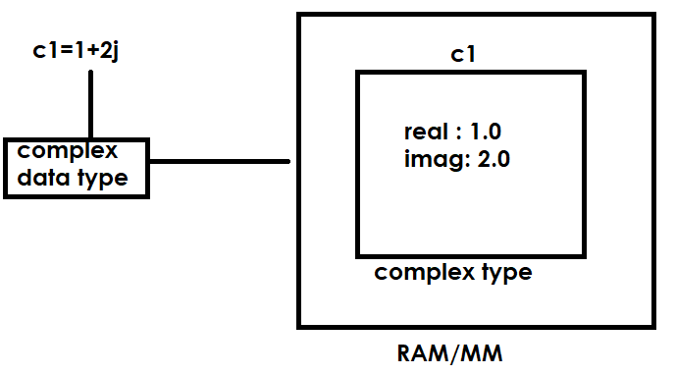
>>> c1=1+2j
>>> c1
(1+2j)
>>> c1.real
1.0
>>> c1.imag
2.0
>>> type(c1.real)
<class 'float'>
>>> type(c1.imag)
<class 'float'>
>>> type(c1)
<class 'complex'>
>>> c2=2j
>>> type(c2)
<class 'complex'>
>>> c2.real
0.0
>>> c2.imag
2.0
>>> c3=5
>>> type(c3)
<class 'int'>
>>> c3
5
>>> c5=1+2i
SyntaxError: invalid decimal literal
>>> c5=1+2j
>>> import math
>>> math.sqrt(9)
3.0
>>> math.sqrt(-9)
Traceback (most recent call last):
File "<pyshell#36>", line 1, in <module>
math.sqrt(-9)
ValueError: expected a nonnegative input, got -9.0
>>> import cmath
>>> cmath.sqrt(-9)
3j

bool datatype and boolean values or literals
boolean values in python are represented using 2 keywords
- True
- False
Bool datatype is used to create space or allocate memory for boolean values.

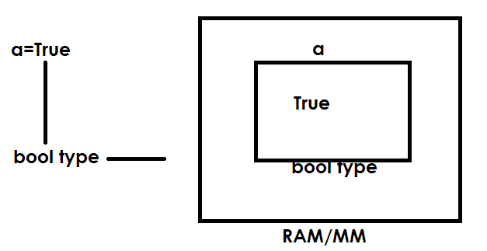

>>> a=True
>>> a
True
>>> type(a)
<class 'bool'>
>>> b=False
b
>>> False
>>> type(b)
<class 'bool'>
>>> True+True
2
>>> True+False
1
>>> False+False
0
>>> True-False
1

In python boolean values can be used to perform arithmetic operations. These boolean values represented as 1 byte integer value.

True 🡪 1
False 🡪 0
>>> rollno=1
>>> fee=9000.0
>>> fee_paid=True
>>> type(rollno)
<class 'int'>
>>> type(fee)
<class 'float'>
>>> type(fee_paid)
<class 'bool'>

NoneType and None value or literal

NoneType datatype is used to represent None value
In application development None values are used as,
- Missing values
- Create a variable by assigning no value

>>> empno=101
>>> ename=None
>>> job=None
>>> sal=5000.0
>>> type(empno)
<class 'int'>
>>> type(ename)
<class 'NoneType'>
>>> type(job)
<class 'NoneType'>
>>> type(sal)
<class 'float'>
>>> a=None
>>> a
>>> type(a)
<class 'NoneType'>

String (OR) str datatype

In python string is collection type.
String is sequence datatype. It organize string data in sequential order.
String is non numeric data type, we cannot perform arithmetic operations on string.
String is collection of characters. These characters can be alphabets, digits or special characters.
The string which contains only alphabets is alphabetic string
This string which contains alphabets and digits is called alphanumeric string.

